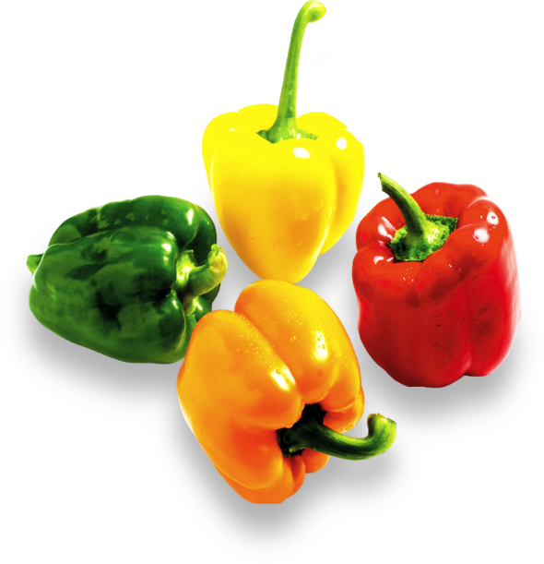



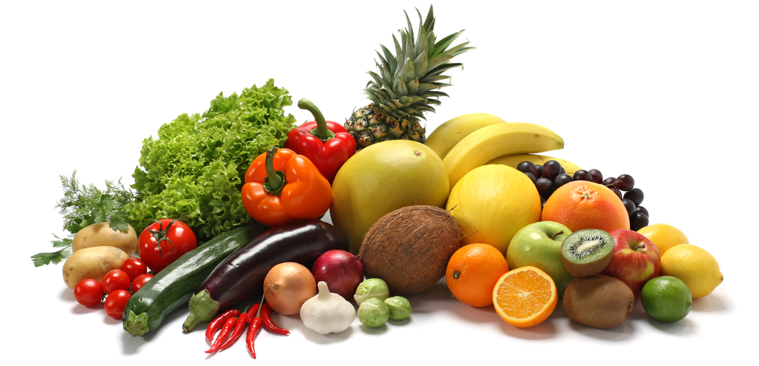

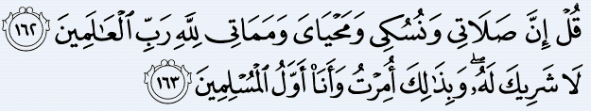

***Say, "Indeed, my prayer, my rites of sacrifice, my living and my dying are for Allah, Lord of the worlds. No partner has He. And this I have been commanded and I am the first [among you] of the Muslims.”[Quran 6:162, 163]***

IBADAH

IN ISLAM

**Every act is considered an act of worship if performed in accordance with the ways prescribed by Allah.**

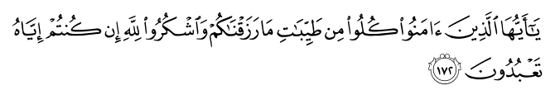

**O you, who have believed, eat from the good things which We have provided for you and be grateful to Allah if it is [indeed] Him that you worship. (Al.Baqarah:172)**

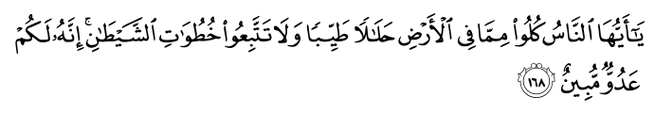

**O mankind, eat from whatever is on earth [that is] lawful and good and do not follow the footsteps of Satan. Indeed, he is to you a clear enemy. (Al.Baqarah:172)**

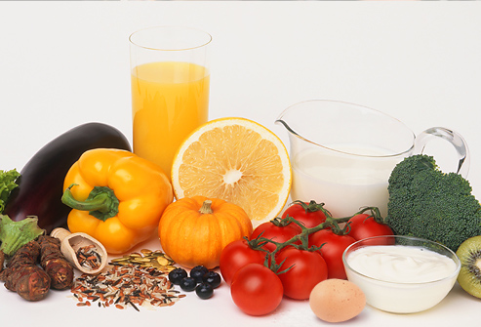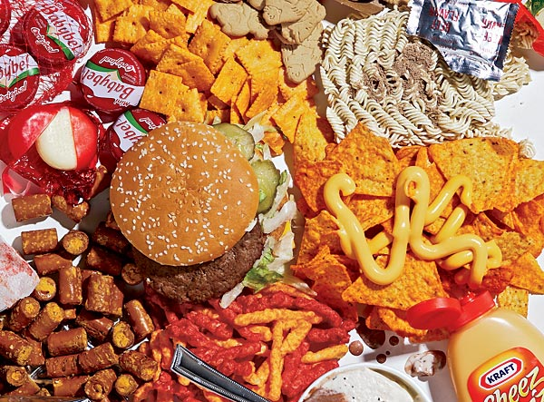

**UNHEALTHY FOOD**



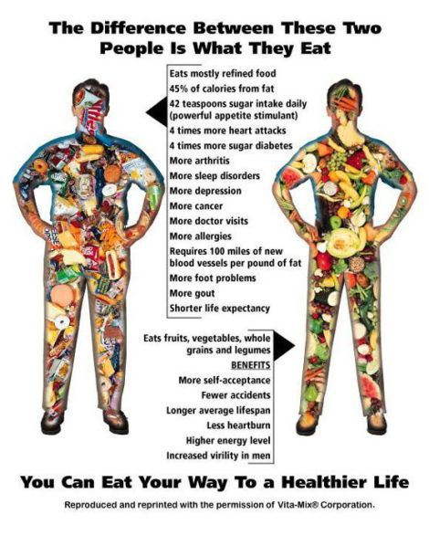

**WHITE FLOUR ITEMS**

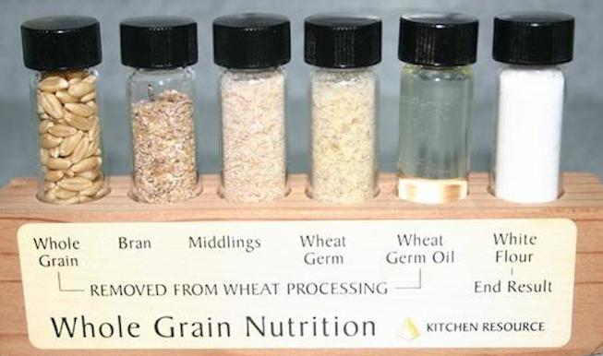

**MARGARINE**

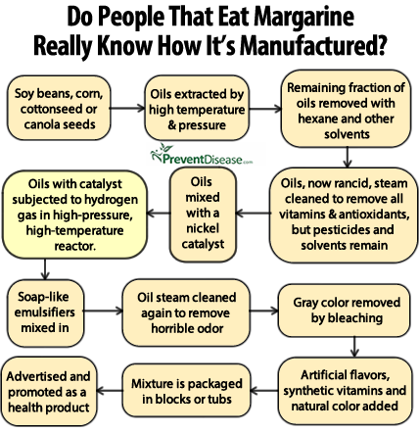

**PROCESSED FOODS**

**FRIZZY DRINKS**

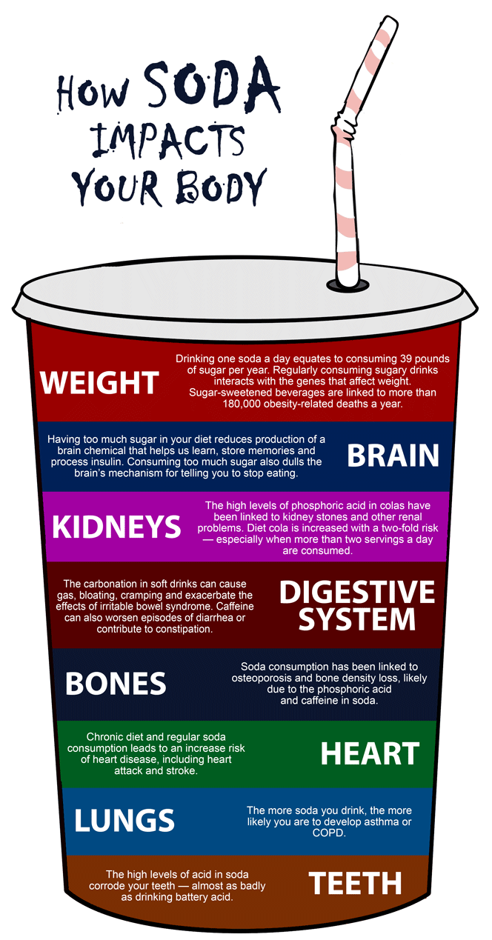

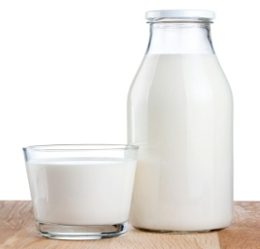

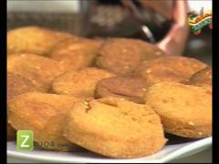

Whole Wheat Grain

* **Home made porridge (wheat or barley).**
* **Chappati or paratha.**
* **Bran bread.**
* **Meethi tikyan.**

**“Stomach is the home of disease. Diet is the main medicine”. (Sahih Muslim)**

**1. *BARLEY (jau):* Good in fever, while use in a soup form.**

**2. *DATES:* The Prophet (صلى الله عليه واله وسلم ) said that a house without dates has no food. It should also be eaten at the time of childbirth.**

**3. *FIGS:* It is a fruit from paradise and a cure for piles.**

**4. *GRAPES:* The Prophet (صلى الله عليه واله وسلم ) was very fond of grapes. It purifies the blood, provides vigor and health, strengthens the kidneys and clears the bowels.**

**5. *HONEY:* Considered the best remedy for diarrhea when mixed in hot water. It is the food of foods, drink of drinks and drug of drugs. It is used for creating appetite, strengthening the stomach, eliminating phlegm; as a meat preservative, hair conditioner, eye soother and mouthwash. It is extremely beneficial in the morning in warm water.**

**6. *MELON:* The Prophetصلى الله عليه واله وسم) ) said: ‘None of your women who are pregnant and eat of water melon will fail to produce off spring that is good in countenance.**

**7. *MILK:* The Prophet (صلى الله عليه واله وسلم) said that milk wipes away heat from the heart just as the finger wipes away sweat from the brow. It strengthens the back, improved the brain, renews vision and drives away forgetfulness.**

**8. *MUSHROOM:* The Prophet (صلى الله عليه واله وسلم ) said that mushroom is a good cure for the eyes; it also serves as a form of birth control and arrests paralysis.**

**9. *OLIVE OIL*: Excellent treatment for skin and hair, delays old age, and treats inflammation of the stomach.**

**10. *POMEGRANTE:* The Prophet (صلى الله عليه واله وسلم) said it cleanses you of Satan and evil aspirations for 40 days.**

**11. *VINEGAR:* Prophet (صلى الله عليه واله وسلم) used to eat it with olive oil.**

**12. *WATER:* The Prophet صلى الله عليه واله وسلم) ) said the best drink in this world is water, when you are thirsty drink it by sips and not gulps, gulping produces sickness of the liver.**

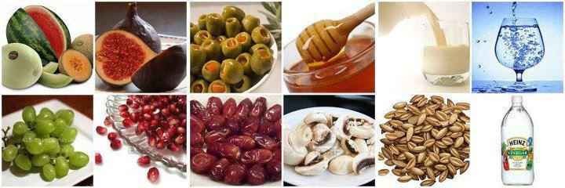

**IF YOU CAN’T OFFORD OR SOMEHOW CAN’T GET THE ORGANIC VEGETABLES THEN TRY TO GROW YOUR OWN IN YOUR KITCHEN!**

**A SQUAREFOOT KITCHEN GARDEN**

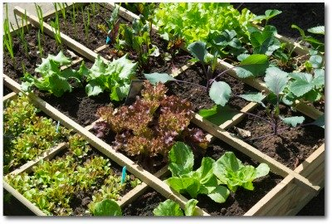

* **Use untreated lumber (either 2 by4's, or 2 by 6's will work fine) cut into 4' 3" lengths.**
* **Nail the ends together to create a square with an inner area of four feet.**
* **Divide the square into 16 equal squares, using strips of wood or strings as dividers.**